
REPUBLIC OF GHANA

COMPOSITE BUDGET

FOR 2026-2029

PROGRAMME BASED BUDGET ESTIMATES

FOR 2026

SEKONDI TAKORADI METROPOLITAN ASSEMBLY

2025


Total Revenue Projection - GH¢ 101,552,377.85

Compensation of Employees Goods and Service Capital Expenditure
GH¢ 33,775,868.00 GH¢ 26,151,809.85 GH¢ 41,644,770.00

Total Expenditure Estimates - GH¢ 101,552,377.85

……………………………… ………………………………
RT. HON PATRICK BREMPONG MR. MOHAMMED ALHASSAN YAKUBU
PRESIDING MEMBER METRO. COORDINATING DIRECTOR

Table of Contents
1
PART A: STRATEGIC OVERVIEW OF THE ASSEMBLY 3
Establishment of the District 3
Population Structure 4
Vision 4
Mission 4
Core Functions 4
District Economy 5
Key Development Issues and Challenges 8
Key Achievements in 2025 8
Adopted Medium Term National Development Policy Framework (MTNDPF) Policy Objectives 11
Policy Outcome Indicators and Targets 11
Revenue Mobilization Strategies 12
PROGRAMME 2: SOCIAL SERVICES DELIVERY 28
PROGRAMME 3: INFRASTRUCTURE DELIVERY AND MANAGEMENT 37
PROGRAMME 4: ECONOMIC DEVELOPMENT 46

PART A: STRATEGIC OVERVIEW OF THE ASSEMBLY

Establishment of the District
The Sekondi Takoradi Metropolitan Assembly was re-established by LI2262 in 2017 following the creation of Effia Kwesiminstim Municipal Assembly.
The Sekondi Takoradi Metropolitan Assembly is located at the western coastline of Ghana about 280km off Accra; the national capital and approximately 130km from La Cote d’Iviore border to the west. The Twin City covers a land area of 119 km2.
It is bordered to the North by Mpohor District, Shama District to the east, Effia-Kwesimintsim Municipal to the west and south by the Gulf of Guinea. The position of STMA along the proposed Abidjan – Lagos corridor highway is strategic and can serve as a transportation hub and a haulage truck terminal with all its advantages.
STMA is one of the fourteen (14) districts in the western region and has total land area of 119 square kilometers. Though it is the smallest in terms of land size, it is most urbanized and densely populated local government area in the Region. Rapid urbanization has put a greater burden on the Metropolis in terms of provision of urban infrastructure and services. To effectively make use of available land for development effort is directed towards adoption of effective land administration and management in the medium term. Preference would be given to construction of high-rise apartments and other socio-economic infrastructure.
The Assembly operates through two main committees: the Executive Committee, now known as the Metropolitan Authority, and the Public Relations and Complaints Committee (PRCC). Additionally, there are seven sub-committees: Development Planning, Works, Finance and Administration, Social Services, Revenue Mobilization, Education, and Environment and Sanitation. There are three Sub-Metropolitan District Councils namely; Sekondi, Takoradi, and Essikado-Ketan with three Constituencies, thirty-six (36) Electoral Areas; fifty-three (53) Honorable Members (10) are women representing 19%. The city covers a total land size of 119 Kilometer square.

Population Structure
Currently STMA has a total population of 267,614 and is projected to be at 273,501 in 2026 at an annual growth rate of 2.2%. This constituted 25.2 percent of the population of the Western Region. The females’ form 49.28% compared to males who constituted 50.72%. The Sub-Metro breakdown from the 2021 census indicates that Takoradi Sub-Metro has a population of 50,065, Sekondi Sub-Metro has 54,772, and Essikado-Ketan has 140,545. An analysis of the population distribution shows that the entire population.

Vision
A World Class City with Modern Infrastructure, Social Services, Best Governance, Attractive business and Living environment.

Mission
To improve the living conditions of the metropolis through the provision of sustainable socio – economic development and good governance that is responsive to the needs of the people.

Core Functions
The Sekondi-Takoradi Metropolitan Assembly (STMA) like other Assemblies derives its functions from sections 245 of the 1992 constitution of the Republic of Ghana as well as the Local Governance Act, Act 936 of 2016. Broadly, these functions are deliberative and executive in nature, and are aimed at attaining the objectives set out above.
The core functions of STMA are outlined below:
- To ensure a healthy human settlement environment through the development and maintenance of infrastructure and utilities services within the metropolis
- To create opportunities for social growth and human development through the provision of equitable access to education, health and other social services.
- To ensure sound waste management practices and improved environmental health and sanitation.
- To ensure efficient revenue generation and transparency in local resource management.
- To facilitate economic growth, employment and income generation through agricultural and local economic development to promote household livelihoods and alleviate poverty.
- In collaboration with the appropriate national and local law enforcement agencies, law, order and public safety in the metropolis;
- Coordinate, integrate and harmonize the execution of programmes and projects under approved development plans for the district, any and other development programmes promoted or carried out by Ministries, departments, public corporations and any other statutory bodies and non-governmental organizations in the district.

District Economy
The profile of the Sekondi-Takoradi Metropolis (STMA) describing the geography and physical characteristics, demographic and built environment characteristics, socio-political and cultural context, economic context shows a reliable domestic revenue base and potential for a sustainable revenue capacity to finance future development
Vegetation
The Metropolis has three main vegetation types, namely, mangrove, coastal scrub and savannah Woodland. The Mangrove and coastal scrub are found in the southern and middle parts whilst the savannah woodland is found in the northern part respectively. In addition, the metropolis is recognized for its Forest Resources notable is the Monkey Hill Conservation Forest which is reserved for eco-tourism.
Geology and Mineral Deposits
Geologically, the Sekondi-Takoradi Metropolitan Assembly (STMA) is predominantly composed of shales and sandstones, which rest on a hard basement of granites, gneiss, and schists. The coastline's landform is shaped by a faulting system, contributing to a high-water table and elevated salt content in the groundwater. Significant stone deposits are mainly located in areas such as Diabenekrom, Essipong, Kojokrom, and Butumagyebu.
Culture and Tourism
The Sekondi-Takoradi Metropolitan Assembly (STMA) is traditionally divided into three paramount areas: Sekondi, Essikado, and Takoradi. The Metropolis has the following ethnic distribution; Fantes, Ahantas , Asantes Nzemas and Wassas. The metropolis boasts several tourism sites with the potential to become major destinations in Ghana. Key heritage sites include Fort Orange and the Old High Court Building in Sekondi. The region also hosts rich cultural festivals such as the Kundum and Masquerading Festival. Natural attractions include the Whin River Estuary, Essei Lagoon/Wetlands, and various beaches that offer beach sports and boat cruises. Additionally, conservation and ecology areas such as the Monkey Hill ecotourism site in Takoradi provide opportunities for bird viewing and exploring the Monkey Walk-bay Botanical Garden.
Health
The Sekondi-Takoradi Metropolitan Assembly (STMA) is served by 64 health facilities, comprising 7 hospitals, 5 health centers, 23 clinics, 2 maternity homes, and 27 functional Community-based Health Planning and Services (CHPS) centers.
Education
The Sekondi-Takoradi Metropolitan Assembly (STMA) is home to approximately 461 educational facilities, encompassing both public and private institutions. Specifically, there are 269 public schools and 188 registered private schools that offer educational services ranging from the basic education level to senior high school. This diverse array of educational institutions plays a crucial role in providing comprehensive education to the youth within the metropolis, ensuring access to quality learning opportunities across different educational stages.
Social Protection
The Assembly’s social protection efforts are categorized into four main programs: Child Rights Promotion and Protection, Justice Administration, Community Care, and the Livelihood Empowerment Against Poverty (LEAP) program, the Ghana National Household Registry (GNHR) initiative, and strengthen the capacity of the Metro Social Protection Committee (MSPC).
Local Economy
Agriculture:
Agriculture remains a vital part of the Metropolis’s economy, providing full-time and part-time employment for about 32% of the population. Approximately 85,000 people are engaged in agriculture, with 8% involved in fishing. Over 73% of the near-rural population depends directly and indirectly on agriculture and related activities for their livelihood. About 35% of the Metropolis’s land area is cultivable, with an average farm size of 2 acres. Most farmers practice subsistence farming, although there are some commercial farms. Farming systems include mixed farming, mixed cropping, and mono-cropping of tree crops such as coconut, oil palm, citrus, and cocoa. Fishing is a common occupation, but many lack the resources to acquire outboard motors, highlighting the need for support to enable more people to enter the fishing industry.
Food Production
Major crops grown include cassava, plantain, maize, rice, yam, and cocoyam. Vegetables, particularly exotic varieties, are also widely cultivated. Commonly reared animals include poultry, sheep, and goats, with cattle reared by a few farmers. There is an increasing trend in the rearing of rabbits, grass cutters, and snails. The Metropolis also has gari, oil palm, and palm kernel processors, with products purchased by soap manufacturers and fish processors in the area.
Industries
The Metropolis's industrial sector includes manufacturing, wood processing, and agro-processing, with manufacturing being the most prominent. Industries specialize in oil palm and rubber products, with wood processing industries primarily located between Sekondi and Takoradi. However, many of these industries operate below capacity or are non-functional. The Ghana Free Zones Board (GFZB) has proposed an industrial site to facilitate an export processing zone in Sekondi.
Takoradi Port and Albert Bosomtwi-Sam Fishing Harbor: Built in 1928, the Takoradi Port is a vital gateway to the middle and northern parts of Ghana and the Sahelian countries of Burkina Faso, Niger, and Mali. The port handles over 600 vessels annually, representing 37% of national seaborne traffic, 62% of national exports, and 20% of total national imports. Also, constructed in 1999, the Albert Bosomtwi-Sam Fishing Harbor in Sekondi is managed as part of Takoradi Port. It includes the Inner Fishing Harbor, the Canoe Basin, and the Outer Fishing Harbor, and is strategically located approximately 25 km west of Takoradi Port, north of Sekondi Naval Base.
Retail Business
The retail landscape of Sekondi-Takoradi is predominantly composed of informal traders. These traders are distributed throughout the city, offering a wide range of products and services. They are primarily concentrated along the main roads and enjoy substantial support from residents.
Mechanics and Local Artisans: The Kokompe No. 1 and No. 2 areas host a significant number of mechanics and local artisans, including wood furnishers, welders, hairdressers, and barbers. Most of these artisans are middle-aged and have little to no formal education, serving primarily local customers from the Sekondi-Takoradi area. The Kokompe areas have access to social services such as electricity, pipe-borne water, toilet facilities, and waste collection, though these facilities require upgrades.
Market Activities: There are two major markets in the Metropolis, including the Takoradi Central Market and Sekondi Market. Each market primarily serves its surrounding communities, with the Takoradi Central Market being the largest and most significant. The Takoradi Central Market was initially built to serve the workers involved in the construction of the Takoradi harbor. It was designed as the central trading hub for STMA. Its strategic location makes it the most accessible market in the Metropolis. Covering one square kilometer, it is the largest market in the Western Region in terms of size, number of traders, and sphere of influence. It lies at the heart of the Central Business District (CBD), surrounded by ancillary services such as banks and insurance companies. The Sekondi Market is the second most vibrant commercial center in the Metropolis, following the Takoradi Central Market.

Key Development Issues and Challenges
The Sekondi Takoradi Metropolitan Assembly has the following key issues;
- Reliance on outdated revenue data for revenue projection and development finance planning.
- Huge multi sectoral infrastructure gap.
- Increasing challenge with city waste and sanitation management.
- Delay in the completion of major government projects in the city - Kwame Nkrumah Interchange, Takoradi Market Circle, Effia Nkwanta Hospital Block, CODA / GET Fund Projects, City Roads, etc.

Key Achievements in 2025
The following are some of the key achievements for the year 2025
- Completion of 1 No. 3 Unit Classroom Block with Ancillary at Inchaban Nkwanta
- Completion of 3 Unit Classroom Block with Offices and Stores at Bishop Essuah- Takoradi.
- Completion of 3 No. Reproductive Health Clinic at Kojokrom, Diabene, Essipong
- Completion of 40 No. Borehole for selected communities in the Metropolis.
- Completion of 9 No. CODA projects
- Completion of 100 No. Eco-Friendly Oven in fishing communities in the Metropolis.
- Completion of final 200 No. Bio-fill Digester Toilet Facilities Metro wide.
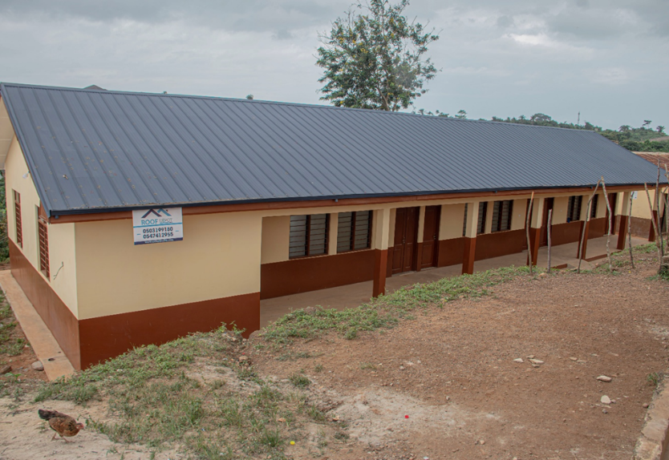
CONSTRUCTION OF 1 NO. 3 UNIT CLASSROOM BLOCK WITH ANCILLARY AT INCHABAN NKWANTA.

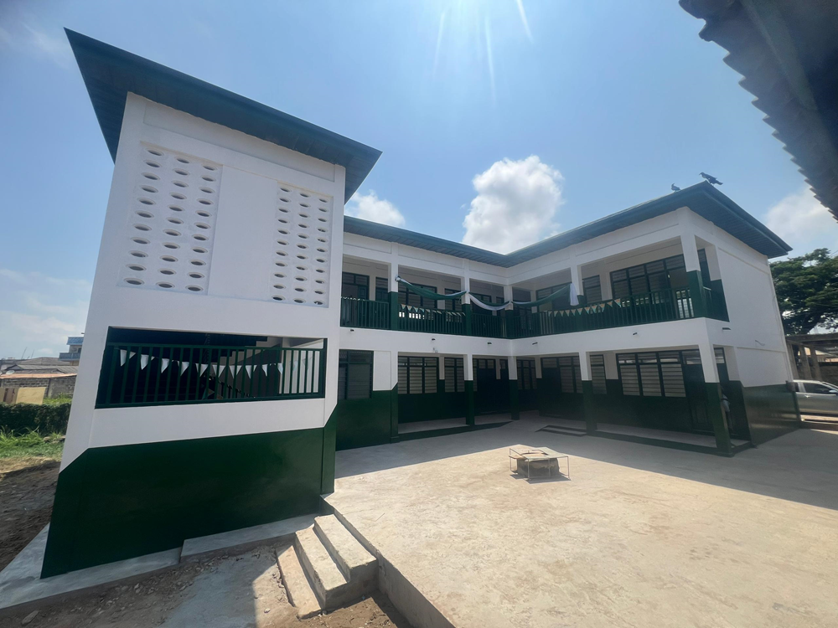

CONSTRUCTION OF 3 UNIT CLASSROOM BLOCK WITH OFFICES AND STORES AT BISHOP ESSUAH -TAKORADI.
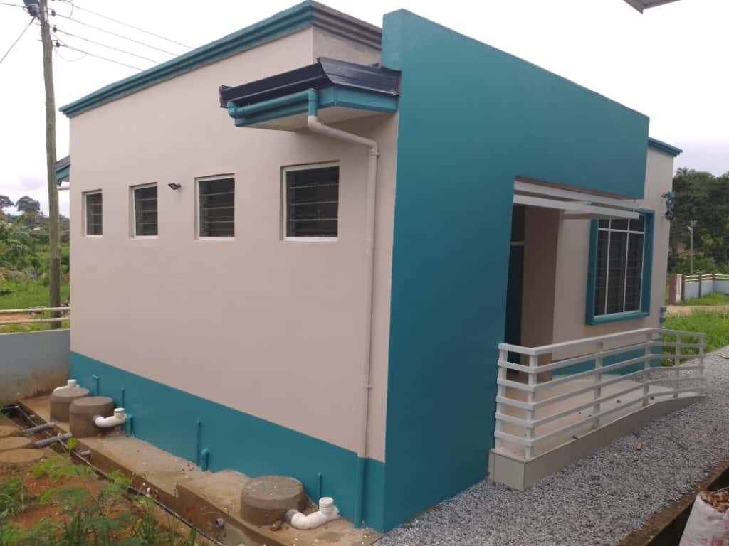

COMPLETION OF 3No. REPRODUCTIVE HEALTH CLINIC AT KOJOKROM, DIABENE, ESSIPONG.
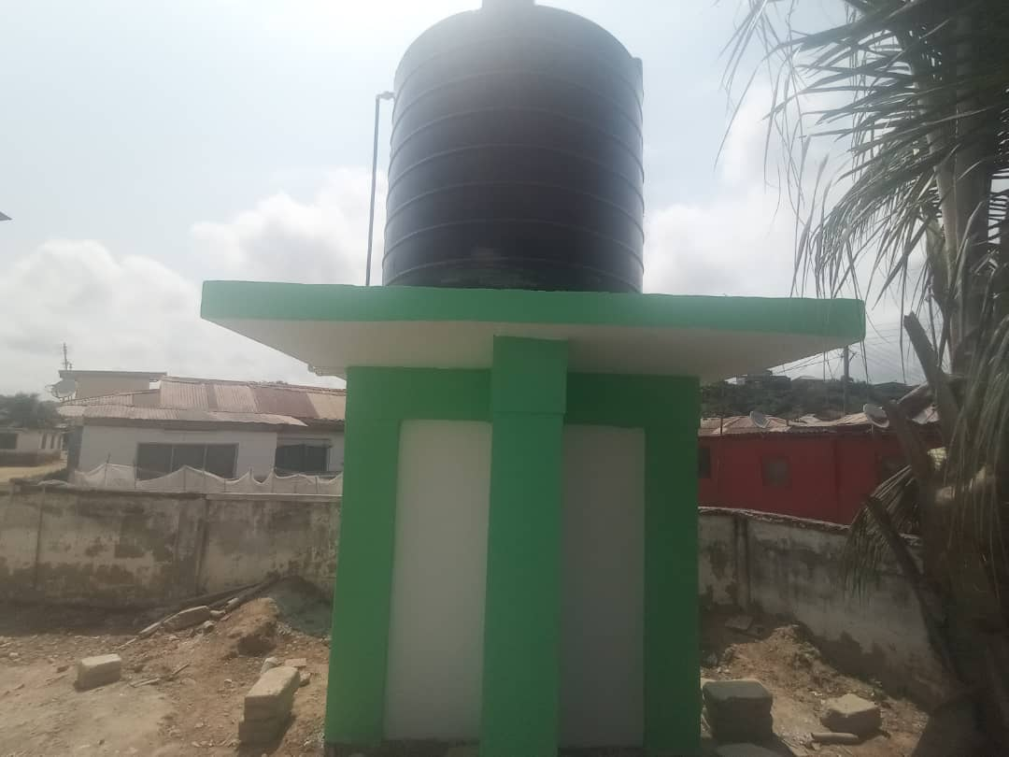
CONSTRUCTION OF 40No. BOREHOLE FOR SELECTED COMMUNITIES IN THE METROPOLIS
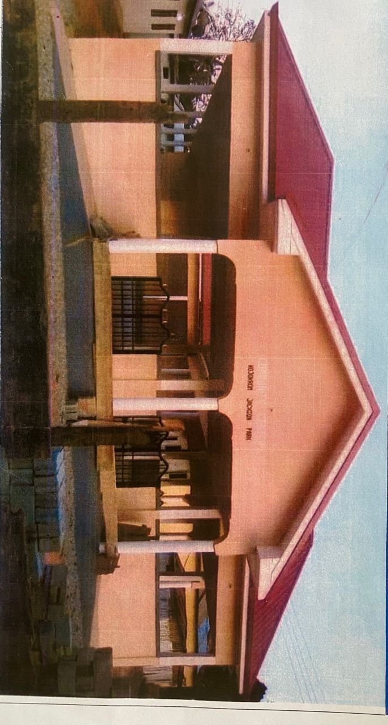
CODA HAS 9No. COMPLETED PROJECTS OUT OF THE 19No. PROJECT RECEIVED AS LEGACY PROJECTS UNDER COMMON FUND (ASSEMBLY)
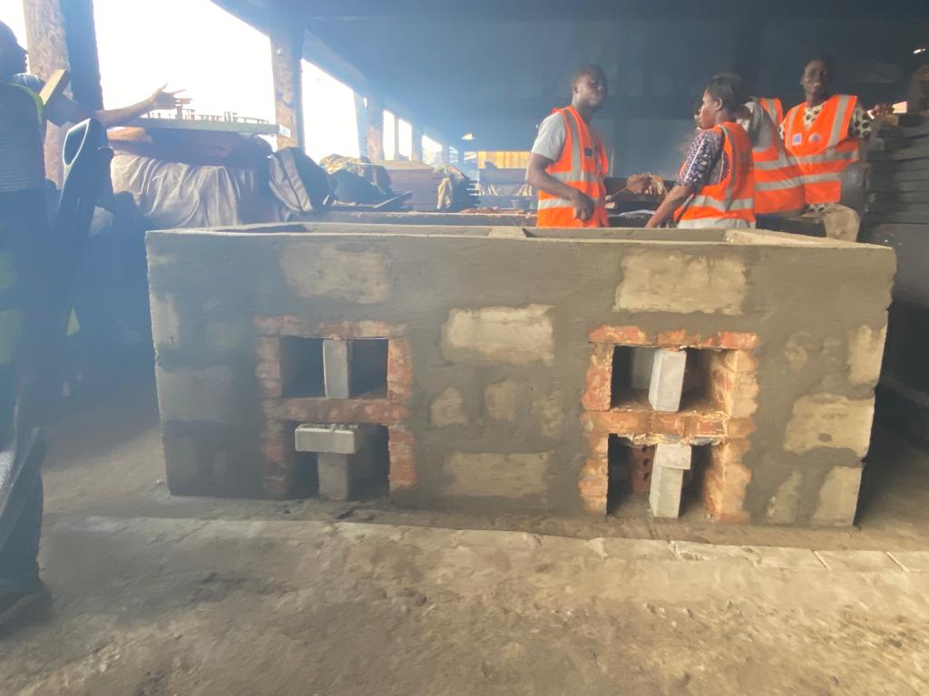
COMPLETION OF 100No. ECO FRIENDLY OVENS IN FISHING COMMUNITIES IN THE METROPOLIS
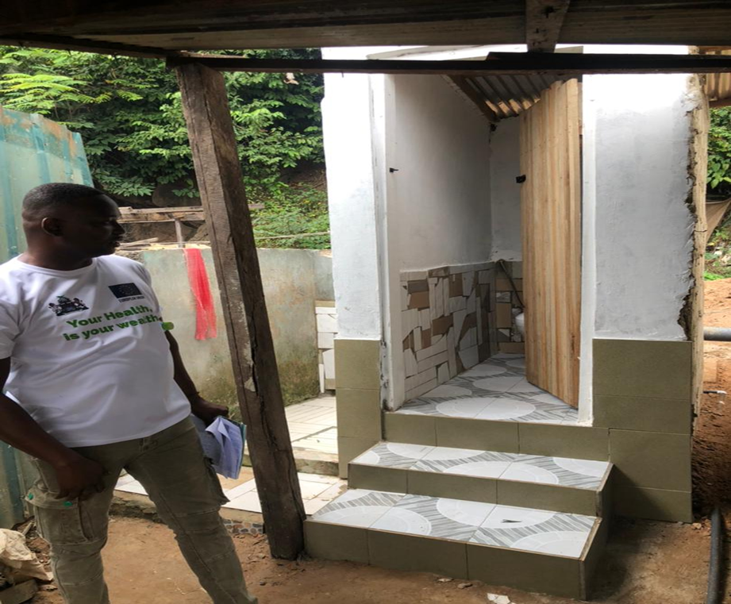
COMPLETED THE FINAL 200No. BIOFILL DIGESTER TOILET FACILITY (400 UNITS IN ALL)

Revenue and Expenditure Performance
The revenue collection of the Metropolitan Assembly is currently at GHc 49,875,962.24 as at September, 2025. This is 6.06% above that of the same period in 2024. Robust revenue initiatives are currently being reviewed to increase performance in 2026.
Expenditure as at September, 2025 is GHc 41,763,270.10. The use of GIFMIS for expenditure processing have been strengthened. About 88% of spending now goes through GIFMIS. This has improved fiscal compliance and transparency significantly.
Revenue
Table 1: Revenue Performance – IGF Only
REVENUE PERFORMANCE – IGF ONLY
ITEMS | 2023 |  | 2024 |  |  | 2025 |  |  |  | % Perf. as at Sept, 2025
ITEMS | Budget | Actuals | Budget | Actuals |  | Budget |  | Actuals as at September
Property Rates | 7,207,387.84 | 2,106,594.57 | 5,707,387.84 | 7,820,951.97 |  | 6,414,479.50 |  | 5,236,252.89 |  | 81.63
Basic Rates | 15,500.00 | 0.00 | 15,500.00 | 0.00 |  | 20,000.00 |  | 0.00 |  | -
Lands | 1,177,376.00 | 1,694,656.07 | 2,527,376.00 | 1,070,814.88 |  | 2,525,488.00 |  | 691,072.57 |  | 18.58
Rents | 2,304,083.36 | 1,239,141.36 | 2,204,683.36 |  | 3,033,439.26 | 2,405,421.00 |  | 614,788.10 |  | 25.56
Licenses | 4,342,187.50 | 3,285,000.07 | 4,761,461.50 |  | 2,987,511.81 |  | 3,516,985.00 |  | 2,412,733.04 |  | 68.60
Fees | 2,893,384.00 | 4,648,531.85 | 3,893,384.00 |  | 3,020,546.60 |  | 3,744,030.00 |  | 2,423,122.56 |  | 64.71
Fines | 173,000.00 | 123,071.75 | 423,000.00 |  | 60,000.00 |  | 324,600.00 |  | 31,485.00 |  | 9.70
Royalties | 892,624.00 | 446,312.00 | 542,624.00 |  | 0.00 |  | 500,000.00 |  | 2,704.71 |  | -
Total | 19,005,542.70 | 13,543,307.67 | 20,075,416.70 |  | 16,048,891.60 |  | 19,451,023.50 |  | 11,409,454.16 |  | 58.66

Table 2: Revenue Performance – All Revenue Sources
REVENUE PERFORMANCE – All Revenue Sources
ITEMS | 2023 |  | 2024 |  | 2025
ITEMS | Budget | Actuals | Budget | Actuals | Budget | Actuals as at Sept | % Perf
Retained IGF | 19,005,542.70 | 13,543,307.67 | 20,075,416.70 | 16,048,891.60 | 19,451,023.50 | 11,409,454.16 | 58.66
GoG -Comp | 11,694,511.00 | 23,912,951.69 | 25,800,806.46 | 30,786,416.61 | 34,388,207.28 | 24,410,947.85 | 70.99
GoG – Goods | 166,000.00 | 74,306.19 | 195,000.00 | 34,513.72 | 212,000.00 | 0.00 | -
DACF -Assembly | 6,547,829.73 | 1,809,180.23 | 4,030,704.00 | 4,023,411.12 | 25,808,947.31 | 8,798,222.97 | 34.10
DACF- PWD | 200,000.00 | 141,300.03 | 200,000.00 | 252,998.09 | 1,162,251.00 | 277,288.34 | 23.86
DACF -MP | 1,530,000.00 | 1,339,759.56 | 6,243,600.70 | 3,303,990.27 | 12,297,600.00 | 2,432,170.74 | 19.78
DACF- RFG IG | 1,787,467.76 | 141,300.03 | 1,483,343.02 | 1,785,396.00 | 1,365,971.00 | 547,743.39 | 40.09
DACF -RFG- CG | 32,294.23 | 0.00 | 51,643.98 | 180,000.00 | 41,571.00 | 41,571.00 | 100.00
DONOR- UNICEF | 35,000.00 | 17,500.00 | 35,000.00 | 35,000.00 | 35,000.00 | 0.00 | -
DONOR- EU | 12,866,432.00 | 13,151,907.00 | 16,347,680.00 | 5,596,390.00 | 6,034,900.00 | 1,958,563.79 | 32.45
DONOR- SYCA | 0.00 | 0.00 | 2,100,000.00 | 0.0 | 2,466,580.00 | 0.00 | -
Total | 53,665,077.42 | 53,990,212.37 | 76,563,194.86 | 62,047,007.41 | 103,264,051.09 | 49,875,962.24 | 48.30

Expenditure

Table 3: Expenditure Performance - All Sources
EXPENDITURE PERFORMANCE (ALL DEPARTMENTS) ALL FUNDING SOURCES
Expenditure | 2023 |  | 2024 |  | 2025 |  | % Perf (as at Sept. 2025)
Expenditure | Budget | Actual | Budget | Actual | Budget | Actual as at Sept. 2025 | % Perf (as at Sept. 2025)
Compensation | 14,261,066.00 | 29,146,975.41 | 28,594,170.46 | 33,250,400.76 | 36,652,179.79 | 25, 705,084.07 | 70.13
Goods and Service | 29,188,270.00 | 17,237,265.59 | 36,975,129.38 | 26,000,534.13 | 33,638,246.35 | 14,698,757.79 | 43.70
Assets | 10,155,740.00 | 5,096,794.90 | 10,993,893.32 | 4,017,647.33 | 32,973,624.95 | 1,359,428.24 | 4.12
Total | 53,605,076.00 | 51,481,035.90 | 76,563,193.16 | 63,268,582.22 | 103,264,051.09 | 41,763,270.10 | 40.44

Adopted Medium Term National Development Policy Framework (MTNDPF) Policy Objectives
The following Policy Objectives were adopted for the 2026 Fiscal year;
- Compensation of Employees
- Strengthen Domestics Resources Mobilization to improve capacity for revenue collection
- Develop efficient accountable and transparent institutions at all levels
- Develop quality sustainable and resilient infrastructure to support economic development and human well-being
- Increase investment to enhance agriculture productivity capacity in developing countries
- Ensure that the poor and vulnerable have equal rights to economic resources
- Provide access to safe, affordable accessible and sustainable transportation system for all.
- Build resilience of population in vulnerable situations, reduce exposure to climate change disaster
- Ensure free, equitable and quality education for all by 2030
- Achieve universal health coverage, including financial risk protection, access to quality health care services.
- Achieve access to adequate and equitable sanitation and hygiene for all

Policy Outcome Indicators and Targets
Table 4: Policy Outcome Indicators and Targets
POLICY OUTCOME INDICATOR | OUTCOME INDICATOR  DESCRIPTION | UNIT OF MEASUREMENT | Baseline - 2024 |  | Current year (2025) |  | Budget year (2026) | Indicative year (2027) | Indicative year (2028) | Indicative year (2029)
POLICY OUTCOME INDICATOR | OUTCOME INDICATOR  DESCRIPTION | UNIT OF MEASUREMENT | Target | actual | target | actual
Improved Retained IGF Management Services Delivery | Delivery of IGF Mobilization Services via automated platforms | Percentage of Rate Payers using automated services | 13 | 11 | 15 | 9.5 | 25 | 35 | 44 | 52
Increased Social Services Delivery | Attract all SIP in National Budget to STMA | Percentage of SIP Delivered /Supported | 42 | 38 | 45 | 38 | 50 | 60 | 65 | 72
Supervised Delivery of Climate Resilient Urban Infrastructure | Approve Building permits guided by STMA Green Rating Policy. | Percentage of building permits which are green and resilient. | 55 | 45 | 50 | 39 | 50 | 56 | 62 | 74
Environmental and Sanitation Management improved | Increase volumes to the Landfill Site | Volume of Waste (Solid / Liquid) Disposed | 182,000 | 125,800 | 195,000 | 141,355 | 195,000 | 196,300 | 198,120 | 201,112

Revenue Mobilization Strategies
The following are some key strategies adopted to pursue rigorous revenue mobilization in the Assembly.
- Improve citizen ownership of the fee fixing resolution
- Comprehensive revenue data collection initiative
- Roll out Twin City Connect to register all businesses in the city.
- Centralize bill management initiative
- Sub metro ceded revenue resolution
- Revenue monitoring programmes
- Automation of revenue payment (Cashless)
- Assembly members quarterly report
- Mainstream MPs Annual Action Plan
- Align sector specific transfers to planned activities

PART B: BUDGET PROGRAMME/SUB-PROGRAMME SUMMARY
PROGRAMME 1: MANAGEMENT AND ADMINISTRATION
Budget Programme Objectives
The objectives under Management and Administration are:
    - To provide administrative support and ensure effective coordination of the activities of the various departments and quasi-institutions under the Assembly.
    - To ensure the effective functioning of all the sub-structures and general Assembly Committees and Sub Committees to deepen the decentralization in the metropolis.
    - To ensure accountable and transparent financial management regime.

Budget Programme Description
This programme provides services such as policy implementation, maintenance of peace and security, planning and budgeting, revenue mobilization and capacity building. It seeks to coordinate, monitor and evaluate the activities of all departments and units within the Metropolis in the implementation of their respective Programmes and policies.
The Management and Administration Budget Programme will be implemented by 248 staff with support Attachment Personnel. The Budget Programme is allocated a total of GH¢ 36,860,152.00
There are seven (7) Budget Sub Programmes under this Budget Programme.
  - General Administration
  - Finance and Audit
  - Human Resource Unit
  - Planning, Co-ordination and Statistics
  - Legislative Oversights
  - Budgeting and Rating
  - Legal Service
SUB-PROGRAMME 1.1 General Administration
Budget Sub-Programme Objective
  - To provide administrative support and ensure effective coordination of the activities of the various departments and quasi-institutions under the District Assembly.
  - To ensure the effective functioning of all the sub-structures to deepen the decentralization process.
Budget Sub-Programme Description
The General Administration Sub-Programme looks at the provision of administrative support and effective coordination of the activities of the various departments through the Office of the Metropolitan Co-ordinating Director. The Sub-Programme is responsible for all activities and programmes related to general administrative services, internal controls, procurement/stores, light vehicle management, public relation, security, records management, management information system, protocol services, client services and radio operations.
This Budget sub-programme facilitates the Assembly’s activities with the various departments, quasi-institution, and Traditional Authorities and also mandated to carry out regular maintenance of the Assembly’s properties.
It also deals with all activities of the 3 sub-metropolitan district councils namely; Takoradi, Sekondi and Essikado-Ketan Sub Metropolitan District Councils.
Under the Sub-Programme the procurement processes of Goods and Services and Assets for the Assembly and the duty of ensuring inventory and stores management is being led by the Procurement/Stores Unit.
The number of staff delivering the sub programme is 141 with funding from GoG transfer, DACF and IGF. The main challenges of this Sub -Programme include untimely release of funds, and inadequate office space. Total allocation for this sub programme is GH¢ 29, 878, 949.00

Main Outputs | Output Indicator  Description | Output  Indicator |  |  |  | Projections
Main Outputs | Output Indicator  Description | Output  Indicator | 2025  Target |  | 2025  Actual  as at Sept | 2026 | 2027 | 2028 | 2029
Organize management meetings. | Management meetings required monthly | The number of meetings organized | 12 |  | 7 | 12 | 12 | 12 | 12
Perform Routine Maintenance of Office ICT Equipment | Routine maintenance required quarterly | The number of maintenances carried out | 4 |  | 2 | 4 | 4 | 4 | 4
Undertake Public Education and Sensitization Exercise | Public education and sensitization organized monthly | The number of publicity exercise undertaken | 12 |  | 14 | 12 | 12 | 12 | 12
Table 5: Budget Sub-Programme Results Statement

Budget Sub-Programme Standardized Operations and Projects
Table 6: Budget Sub-Programme Standardized Operations and Projects
Standardized Operations | Standardized Projects
Facilitate the organization of annual masquerading carnivals.
Facilitate the organization of "Yesu Asor" Easter carnivals. | Rehabilitation of Office Building at Essikado Sub Metro
Support the celebration of Kundum Festival. | Acquisition of Land
Organize at least 3 General Assembly and Metropolitan Authority meeting, and organize bi-monthly Education subcommittee.
Procure stationery tyre, batteries and chemicals.

SUB-PROGRAMME 1.2 Finance and Audit
Budget Sub-Programme Objective
To ensure accountable and transparent financial management regime and advise Management on the effectiveness of risk management controls and governance processes.
Budget Sub-Programme Description
The Sub-Programme looks at the provision of accountable and transparent management of resources and provision of reliable assurance and consulting services to management on the effectiveness of the control system in place to mitigate risk and promote the control culture of the institution which includes:
  - ensuring access at all reasonable times to files, documents and other records of the Metropolitan Assembly;
  - keeping, rendering and publishing statements on Public Accounts,
  - keeping receipts and custody of all public and trust monies payable into the consolidated Fund;
  - facilitating the disbursement of legitimate and authorized funds
  - preparing financial reports at specific periods of the Assembly
  - preparing payment vouchers and financial encumbrances
  - undertake revenue mobilization activities of the Assembly and assisting other departments of the Assembly in their financial reports
  - Reviews and updates of audit programs;
  - Provides technical leadership in setting up of a functional Audit Report Implementation Committee
The Sub-program operations and major services delivered include: undertaking revenue mobilization activities of the Assembly; keep, render and publish statements on Public Accounts; keep receipts and custody of all public and trust monies payable into the Assembly’s Fund; and facilitates the disbursement of legitimate and authorized funds.
The Sub-Programme is manned by thirty-seven (41) officers comprising of Accountants, Internal Auditors, Revenue Officers and Commission collectors with funding from GoG transfers and Internally Generated Fund (IGF). This Sub-Programme in delivering its objectives is confronted by inadequate office space for accounts officers, inadequate data on ratable items and inadequate logistics for revenue mobilization and public education and sensitization. Total allocation for this sub programme is GH¢ 3,169, 637.00
Table 7: Budget Sub-Programme Results Statement
Main Outputs | OUTPUT INDICATOR DESCRIPTION | Output  Indicator | Past Years |  | Projections
Main Outputs | OUTPUT INDICATOR DESCRIPTION | Output  Indicator | 2025  Target | 2025  Actual as At Sept | 2026 | 2027 | 2028 | 2029
Annual and monthly financial reports prepared and submitted. | Preparation of Financial Statement required monthly | No. of Reports prepared and submitted | 12 | 8 | 12 | 12 | 12 | 12
Build Capacity of  Revenue  Collectors | Train Revenue Collectors semi-annually | No. of trainings conducted | 2 | 0 | 2 | 2 | 2 | 2
Conduct Internal audit reviews | Audit Reviews performed quarterly | No. of audit reviews activities conducted | 4 | 2 | 4 | 4 | 4 | 4

The table indicates the main outputs, its indicators and projections by which the Assembly measure the performance of this sub-programme. The past data indicates actual performance whilst the projections are the Assembly’s estimate of future performance.

Table 9: Budget Sub-Programme Results Statement
Standardized Operations | Standardized Projects
Preparation and Submission of monthly trial balance
Preparation of annual accounts
Promote revenue collection

SUB-PROGRAMME 1.3 Human Resource Management
Budget Sub-Programme Objective
To ensure that the Assembly has adequate qualified and competent employees in the right place and at the right time and at the right cost in order to deliver its mandates and targets.
Budget Sub- Programme Description
The Human Resource Management seeks to improve the departments, division and unit’s decision making and build capacity of the manpower which will ultimately improve the workforce and organizational effectiveness. In carrying out this sub-Programme it is expected that productivity would be enhanced at the Assembly as well as decision making in the management of Human Resource.
Major services and operations delivered by the sub-program include human resource auditing, performance management, service delivery improvement, upgrading and promotion of staff. It also includes Human Resource Management Information System which ensures frequent update of staff records through electronic means, guaranteeing efficient and good salary administration, facilitation of recruitment and selection as well as postings of competent staff to fill available vacancies at the Assembly.
Under this, seven (8) staff will carry out the implementation of the sub-Programme with main funding from GoG transfer and Internally Generated Fund. The sub-Programme would be beneficial to staff of the Departments of the Assembly, Local Government Service Secretariat and the general public.
Budget Sub-Programme Results Statement
The table indicates the main outputs, its indicators and projections by which the Assembly measure the performance of this Sub-Programme. The past data indicates actual performance whilst the projections are the Assembly’s estimate of future performance. Total allocation for this sub programme is GH¢ 942, 723.00

Table 9: Budget Sub-Programme Results Statement
Main Outputs | Output Indicator Descriptions | Output  Indicator | Past Years |  | Projections
Main Outputs | Output Indicator Descriptions | Output  Indicator | 2025  Target | 2025 | 2026 | 2027 | 2028 | 2029
Organize Staff Appraisal Sessions | Staff are required to do quarterly appraisal sessions | Number of staff appraisal sessions organized | 4 | 2 | 4 | 4 | 4 | 4
Conduct Trainings for Staff | Staff training conducted yearly | Number of staff trainings conducted | 2 | 1 | 2 | 2 | 2 | 2
Update Staff Data | Staff data required to be updated quarterly | Number of staff data updated | 4 | 2 | 4 | 4 | 4 | 4

Budget Sub-Programme Standardized Operations and Projects

Table 10: Budget Sub-Programme Standardized Operations and Projects
Standardized Operations | Standardized Projects
Training of 1 Staff on HRD and Labor Laws
Staff Selection and Recruitment Coordination and Implementation
Assembly Members/ Staff Welfare (Funerals, Medical Support, Wedding, etc.)
Organize Orientation for Newly Posted Staff, NSP and Attachment Students & end of service package for NSP

SUB-PROGRAMME 1.4 Planning, Coordination and Statistics
Budget Sub-Programme Objective
  - To provide reliable and responsive statistical services for good governance and development
  - Coordinate in the preparation of development plans for the metropolis
Budget Sub-Programme Description
The Planning, Coordination and Statistical Sub-Programme looks at the provision of reliable data for evidence-based decision making. The Sub-Programme is responsible for all statistical data production and dissemination. The core function of the Statistics is to harness, produce and manage quality local level statistics based on national standards using competent Staff for evidence-based decision making in support of local and national development
The number of Staff delivering the sub-Programme is Thirty (26). The source of funding is from GoG transfers and the Assembly’s Internally Generated Funds (IGF). The main challenge of this sub-Programme we encounter are inadequate, delay and untimely release of funds
Budget Sub-Programme Results Statement
The table indicates the main outputs, its indicators and projections by which the Assembly measure the performance of this sub-Programme. The past data indicates actual performance whilst the projections are the Assembly’s estimate of future performance. Total allocation for this sub programme is GH¢ 1,051,466.00
Table 11: Budget Sub-Programme Results Statement
Main Outputs | Output Indicator Descriptions | Output  Indicator | Past Years |  | Projections
Main Outputs | Output Indicator Descriptions | Output  Indicator | 2025  Target | 2025  Actual as At  September | 2026 | 2027 | 2028 | 2029
Preparation and submission of annual action plan | Required to prepare annual action plan | Number of action plan prepared annually | 1 | 1 | 1 | 1 | 1 | 1
Build Staff Capacity in Data Management and Analysis | Staff Capacity built semi-annually | Number of staff trained in data management and analysis | 2 | 1 | 2 | 2 | 2 | 2

Budget Sub-Programme Standardized Operations and Projects

Table 12: Budget Sub-Programme Standardized Operations and Projects
Standardized Operations | Standardized Projects
Implementation of STMA’s policy to promote green building
Conduct quarterly administrative, revenue and gender statistics
Provision for quarterly MPCU Meetings

SUB-PROGRAMME 1.5 Legislative Oversights

Budget Sub-Programme Objective
Legislative Oversight seeks to ensure that the Executives and Management, or to whom authority is delegated remain responsive and accountable

Budget Sub- Programme Description

The Legislative Oversight Sub Programme looks at convening and presiding over meetings of the Assembly and any other function designated for better decision making.
The sub-Programme is delivered through the Presiding Member in collaboration with Assembly
Members and Management. The source of funding is from GoG transfers and the Assembly’s Internally Generated Funds (IGF). The main challenge of this sub-Programme encounters is inadequate, delay and untimely release of funds.
Budget Sub-Programme Results Statement
The table indicates the main outputs, its indicators and projections by which the Assembly measure the performance of this sub-Programme. The past data indicates actual performance whilst the projections are the Assembly’s estimate of future performance. Total allocation for this sub programme is GH¢ 182,860.00
Table 13: Budget Sub-Programme Results Statement
Main Outputs | Output Indicator Description | Output  Indicators | Past Years |  | Projections
Main Outputs | Output Indicator Description | Output  Indicators | 2025  Target | 2025 Actuals as at August | 2026 | 2027 | 2028 | 2029
Sub-structures strengthened | Required meetings by the Sub Structures | No. of Sub  Metropolitan  Council  Meetings held | 4 | 2 | 4 | 4 | 4 | 4
Organize General Assembly and all related meetings | All Committee and Sub Committee meetings held quarterly | Number of Meetings held | 33 | 18 | 33 | 33 | 33 | 33

Budget Sub-Programme Standardized Operations and Projects

Table 14: Budget Sub-Programme Standardized Operations and Projects
Standardized Operations | Standardized Projects
Organize Staff Trainings and Sensitization for Assembly Staff and Members
Training for Ass. Members on Bye Laws
NALAG Dues

SUB-PROGRAMME 1.6 Budgeting and Rating

Budget Sub-Programme Objective
- To co-ordinate the preparation of the composite budget in the Metropolis
- Assist departments and sub metro in the preparation of their budgets
- Analyze financial statements periodically and advise management on the implications.
In accordance with relevant laws and regulations for sustainable economic development within the Metropolis.

Budget Sub-Programme Description
The Budget and Rating Department seeks to liaise with departments in the areas of budget preparation and coordination, implementation, performance reporting, rating and billing. In carrying out this sub-programme it is expected that productivity would be enhanced at the Assembly as well as decision making.
Major services and operations delivered by the sub-program include budget preparation and coordination, budget implementation, rating and billing, printing and distribution of bills. It also includes coordination of fee fixing preparation, fee fixing engagement which ensures collaboration with all rate payers to determine the amount of rate payable by them.
Under this, twelve (11) staff are delivering the implementation of the sub-Programme including Budget Analysts and Secretaries with main funding from Donor, GoG transfer, DACF and Internally Generated Fund. The sub-Programme would be beneficial to staff of the Departments of the Assembly, Local Government Service Secretariat and the general public.

Budget Sub-Programme Results Statement

The table indicates the main outputs, its indicators and projections by which the Assembly measure the performance of this sub-programme. The past data indicates actual performance whilst the projections are the Assembly’s estimate of future performance. Total allocation for this sub programme is GH¢ 1,445,860.00
Table 15: Budget Sub-Programme Results Statement

Main Outputs | Output Indicator Description | Output  Indicator | Past Years |  | Projections
Main Outputs | Output Indicator Description | Output  Indicator | 2025  Target | 2025  Actual as At September | 2026 | 2027 | 2028 | 2029
Organize Committee  Meetings | Required to organize quarterly meetings | Number of meetings organized | 4 | 2 | 4 | 4 | 4 | 4
Stakeholder Engagement for Fee Fixing | Stakeholder engagement required for fee fixing resolution | Number of  Stakeholder (Group) Engagement  for Fee Fixing Held | 20 | 16 | 28 | 30 | 34 | 38
Analysis of  Financial  Performance | Require to perform analysis on financial statements | No of Analysis undertaken | 12 | 7 | 12 | 12 | 12 | 12

Budget Sub-Programme Standardized Operations and Projects

Table 16: Budget Sub-Programme Standardized Operations and Projects
Standardized Operations | Standardized Projects
Conduct Stakeholders’ engagement.
Preparation of revenue improvement action plan. (RIAP)
Bill printing distribution and monitoring | Procurement of Double Cabin Pickup for Main Office
Preparation of fee-fixing and gazette.
Training on fee-fixing and bills distribution.
Implementation of RIAP
Revenue projection compensation, Goods and Services, Fixed Asset Estimation.
Implement metro budget support programme

SUB-PROGRAMME 1.7 Legal Service

Budget Sub-Programme Objective
  - Provide Legal advice to the Assembly;
  - Assist or facilitate the drawing up of rules and regulations to guide the activities of the Assembly;
  - Represent the Assembly in all legal proceedings;

Budget Sub-Programme Description
The Legal Department being an indispensable component of the Assembly and generally described as Advisory/Support Services Department, collaborates with all the departments under the Assembly in the discharge of its duties i.e., Legal Proceedings, Marriage Registration, Capacity Building etc.
The Legal Department is responsible for legal action against any entity and or organizations, the department from whom such activity emanates must feed the Legal Department with all necessary information needed to proceed to court. Major services and operations delivered by the sub-program include Prosecution of rate defaulters, Marriage registration and capacity building for staff. Under this, three (3) staff are carrying out the implementation of the sub-Programme with main funding from GoG transfer, DDF and Internally Generated Fund.

Budget Sub-Programme Results Statement
The table indicates the main outputs, its indicators and projections by which the Assembly measure the performance of this sub-programme. The past data indicates actual performance whilst the projections are the Assembly’s estimate of future performance. Total allocation for this sub programme is GH¢ 188, 658.00

Table 17: Budget Sub-Programme Results Statement.

Main Outputs | Output Indicator Description | Output  Indicator | Past Years |  | Projections
Main Outputs | Output Indicator Description | Output  Indicator | 2025  Target | 2025  Actual as At September | 2026 | 2027 | 2028 | 2029
Organize Public Education on marriages | Required to organize Education on Marriages | Number of public educations conducted | 4 | 2 | 4 | 4 | 4 | 4
Training of  Assembly  Members  On bye laws | Training required to educate Assembly Members on bye laws | Number of trainings organized | 3 | 1 | 3 | 3 | 3 | 3

Budget Sub-Programme Standardized Operations and Projects

Table 18: Budget Sub-Programme Standardized Operations and Projects
Standardized Operations | Standardized Projects
Supervision of Criminal Prosecution
Representation in Civil Prosecution
Organize ADR Trainings for the complaints committee of the Assembly
Capacity Building for Registrar and Staff
Annual Subscriptions (Acts & Gazette Publications)

PROGRAMME 2: SOCIAL SERVICES DELIVERY

Budget Programme Objective
To improve the social well-being through the promotion of development and social intervention services with equity for the disadvantaged and vulnerable. The Programme objective is to develop a healthy human resource base through education to create opportunities for all to increase productivity.

Budget Programme Description
The Programme objective is to develop a healthy human resource base through education to create opportunities for all to increase productivity. The Social Service Delivery Programme seeks to create the enabling environment necessary for the people within the Metro to improve access to educational health and social welfare services. The Programme is made up of three (3) main sub-programmes consisting:
- Education and Youth Development
- Health Delivery, and
- Social welfare and Community Development (SWCD).
The Program is mainly delivered through Metro Education Directorate, Metro Health Directorate and the Department of Social welfare and Community Development. The Sub program is being implemented with the total support of all staff of the three departments. The total staffs of 14 are involved in the delivery of the Programme (especially SWCD). It must be noted however that, the staff data of the first two departments are captured by their respective Ministries. Consequently, the Assembly does not capture that though the Assembly acknowledge their existence and their immense contribution to the success of the Programme in the Metro. Th programme is being run with a total budget allocation of GH¢ 27,398,966.00

SUB-PROGRAMME 2.1 Education, Youth and Sports Services
Budget Programme Objective
To improve the social well-being through the promotion of development with equity for the disadvantaged. The Programme objective is to develop a healthy human resource base through education to create opportunities for all to increase productivity.
Budget Programme Description
The Metro Directorate of Education is the focal point for the implementation of approved national policies and programmes relating to pre-tertiary (Basic Education, Senior High School Education, Technical and Vocational Education and Special) in the Metropolis. The Directorate is made of up of the Metro Director of Education (MDE) who is assisted by four(4) frontline Assistant Directors and two (2) other unit heads such as : Assistant Director -Human Resource, Management and Development (HRMD) : Assistant Director- Administration, Budget and Financial Control (A&F): Assistant Director -Supervision and Management of Teaching and Learning, Guidance & Counseling and Inspection: Assistant Director Planning, Monitoring, Data Collection, Research &Records: The Metro Education Accountant: The Metro Education Internal Auditor.
The Metropolis is divided into nine (9) circuits which are supervised by nine circuit supervisor and scheduled officers. These include guidance and counseling, SHEP, Special Education, sports /cultural, STMIE organizers. The rest are SHS, examinations, basic schools, girl child, and private schools’ coordinators. The nine circuits include
- Adiembra Circuit
- Nkruful/Kansaworodo Circuit
- Essikado Circuit
- Ketan Circuit
- Kojokrom Circuit
- Sekondi Circuit
- Takoradi East Circuit
- Takoradi West Circuit
- Takoradi Central Circuit

Budget Sub-Programme Results Statement
The table indicates the main outputs, its indicators and projections by which the MMDAs measure the performance of this sub-Programme. The past data indicates actual performance whilst the projections are the MMDA’s estimate of future performance. Total allocation for this sub programme is GH¢ 12, 821,497.00
Table 19: Budget Sub-Programme Results Statement
Outcome  Indicators | Outcome  Indicator Description | Unit of  Measurement | Baseline - 2024 |  | Current Year 2025 |  | Budget Year | PROJECTIONS
Outcome  Indicators | Outcome  Indicator Description | Unit of  Measurement | Target | Actual | Target | Actual | 2026 | 2027 | 2028 | 2029
Improve quality and access to education | Required improvement to access to education | Gender  Parity Index  KG  Primary  JHS  SHS | 1.00  1.00  1.00  1.00 | 0.98  0.97  0.98  0.99 | 1.00  1.00  1.00  1.00 | 1.03  1.04  1.03  1.03 | 1.00  1.00  1.00  1.00 | 1.00  1.00  1.00  1.00 | 1.00  1.00  1.00  1.00 | 1.00  1.00  1.00  1.00
Improve quality and access to education | Required improvement to access to education | Gross Enrolment rate  KG  Primary  JHS  SHS | 70.00  79.50  65.00  68.50 | 71.00  85.50  69.00  68.50 | 75.00  85.50  70.00  75.50 | 60.00  78.00  65.00  66.50 | 75  86  70  72 | 75  88  75  78 | 80  90  75  80 | 80  90  75  85
Improve quality and access to education | Required improvement to access to education | % Pass in  BECE | 97 | 97 | 98 | 97 | 98 | 98 | 98 | 98
Improved Extension  services to farmers | Extension services improved required | Number of  farmers  reached | 2,450 | 2,259 | 2,510 | 2,280 | 2,600 | 2,700 | 2,700 | 2,700

Budget Sub-Programme Standardized Operations and Projects

Table 20: Budget Sub-Programme Standardized Operations and Projects
Standardized Operations | Standardized Projects
Organize my first day at school | Construction of 3-unit class room block at Inchaban Nkwanta
Organize BECE and Mock foe BECE candidates | Construction of 3-unit class room block at Mbredane
Organize STMIE | Construction of 6-unit class room block at Nana Kobina Gyan
Organize Independence Day celebration for KG in the Metropolis | Supply of 300No. Octagon Tables and Chairs
 | Supply of 1200 no. mono desk for public junior high schools
 | Construction of 1no 2 unit class room block at Prophet Nkansah

SUB-PROGRAMME 2.2 Public Health Services and Management

Budget Sub-Programme Objective
The objective of the programme is to provide and prudently manage comprehensive and accessible quality health services with emphasis on Primary Health Care in accordance with approved national policies. The main strategy for implementing Primary Health Care is the provision of Community-based Health Planning and Services (CHPS).
Specifically, the objectives of the programme are:
To implement approved national policies for health delivery in the metropolis.
To increase access to good quality health service; and
To manage prudently resources available for the provision of the Health Service.
Budget Sub-Programme Description
The sub programme seeks to bridge the equity gaps in geographical access to health services and ensure a sustainable financing for healthcare delivery and financial protection for the poor. The sub programme seeks to improve quality of health services delivery including mental health services and also work towards intensifying the prevention and control of non-communicable diseases.
The sub programme is delivered through professionalism, teamwork, integrity, discipline, excellence and people centeredness as their core values. It is managed by the Office of the Metropolitan Health Department, the Disease control unit, the Maternal and Child Health (MCH) unit, the medical stores, Data management Unit and the sixty-three (63) health facilities in the metropolis. The sub programme has staff strength of 800 consisting of core health personnel and other supporting staff. Funding for the sub-programmes is mainly from GOG, the DACF, IGF and other donor funded sources.
Budget Sub-Programme Results Statement
The table indicates the main outputs, its indicators and projections by which the MMDAs measure the performance of this sub-programme. The past data indicates actual performance whilst the projections are the MMDA’s estimate of future performance. Total allocation for this sub programme is GH¢ 9,291,101,00

Table 21: Budget Sub-Programme Results Statement
MAIN OUTPUT | OUTPUT  INDICATOR DESCRIPTION | OUTPUT  INDICATOR | BASELINE - 2024 |  | 2025 PERFORMANCE |  | BUDGET YEAR | PROJECTIONS
MAIN OUTPUT | OUTPUT  INDICATOR DESCRIPTION | OUTPUT  INDICATOR | Target | 2024  Actual | Target | Actual | 2026 | 2027 | 2028 | 2029
Increase in access to  health facilities | Required increase to health facilities | No. of  Health  Centers  Constructed | 3 | 2 | 4 | 3 | 4 | 4 | 5 | 4
Reduction in Malaria cases | Malaria cases reduced | No. of  Reported cases | 51982 | 45645 | 46753 | 34890 | 37870 | 39654 | 40125 | 41990
Access to  Health  Services  Improved | Required access to improved health facilities | OPD per  Capita | 2 | 1 | 3 | 4 | 5 | 6 | 8 | 10

Budget Sub-Programme Standardized Operations and Projects

Table 22: Budget Sub-Programme Standardized Operations and Projects
Standardized Operations | Standardized Projects
Conduct quarterly awareness on HIV meetings | Adolescent Health Centre at Kojokrom
Conduct quarterly monitoring and supportive on routine immunization | 1 No. Enhanced CHPS compound at Ketan- BU
 | 1 No. Enhanced CHPS at Kojokrom

SUB-PROGRAMME 2.3 Social Welfare and Community Development
Budget Sub-Programme Objective

    - To take the lead in integrating the disadvantaged, vulnerable and excluded in mainstream development
    - To work in partnership with people in their communities to improve their social well-being though promoting development with equity for the disadvantaged, vulnerable and excluded.
Budget Sub-Programme Description
- Provide case management services to children in need of care and protection
- Promote family and child welfare policy
- Promote access to social services to the disadvantaged, vulnerable and marginalized group
- Provide community-based rehabilitation programmes to persons with disabilities
- Co-ordinate and regularize specialized residential and other services for children, under privileged, youth and persons with disabilities
- Facilitate opportunities for NGOs to develop social services in collaboration with communities
- Create awareness on the prevention and control of HIV/AIDS in collaboration with other agencies and promote country care strategies
- Provide social protection services to the disadvantaged, vulnerable and excluded
- Secure maximum standard of operation on day care centers through registration, training and regular inspection under the children’s Act (560) of 1998
- Provide hospital welfare services
- Facilitate and coordinate programmes for the elderly including community-based programmes ● Provide adult education
- Promote community development programmes
- Provide skills development training for five income generating groups.
Budget Sub-Programme Results Statement
The table indicates the main outputs, its indicators and projections by which the MMDAs measure the performance of this sub-programme. The past data indicates actual performance whilst the projections are the MMDA’s estimate of future performance. Total allocation for this sub programme is GH¢ 4,810,863.00
Table 23: Budget Sub-Programme Results Statement
MAIN OUTPUT | OUTPUT  INDICATOR DESCRIPTION | OUTPUT  INDICATOR | Past Years |  | Projections
MAIN OUTPUT | OUTPUT  INDICATOR DESCRIPTION | OUTPUT  INDICATOR | 2025  Target | 2025  (as at  September) | 2026 | 2027 | 2028 | 2029
Provide Case management  Social Services | Required management cases provided  annually | Case management  services for 420 children provided | 400 | 311 | 420 | 420 | 420 | 420
Promote Child and family welfare policy | Promotion of family welfare policy annually | Community engagement in 15 communities with child protection toolkit to promote child and family welfare policy held | 15 | 10 | 15 | 15 | 15 | 15
Promote Stake holders’  collaboration | Required stake holders’ collaboration | One review meeting for 30 stakeholders organized | 1 | 1 | 1 | 1 | 1 | 1
Provide Social Service to Hospitals | Provision of social services to hospitals required | Social Service provided to 2  Hospitals | 2 | 1 | 2 | 2 | 2 | 2
Adult education provided | Required number of adult educations provided | 25No. income generation group reactivated | 20 | 14 | 25 | 25 | 25 | 25

Budget Sub-Programme Standardized Operations and Projects

Table 24: Budget Sub-Programme Standardized Operations and Projects
Standardized Operations | Standardized Projects
Facilitate LEAP Payment | Construction of community center at Kojokrom
Provide skill training and development for income generating group | Construction of community center at Mpentemsrew
Trace families of abandoned children | Construction of community center at Nkestsiakrom
Provide psychological support for patients | Construction of Astro Turf at Fijai
Register and provide support to PWDs
Promote adult education for 3 groups
Monitor and supervise day care center’s
Update data on PWDs

SUB-PROGRAMME 2.4 Birth and Death Registration Services
Budget Sub-Programme Objective
  - To increase accessibility of our services to the communities in the hinterland to enhance birth and death registration.
  - To have adequate database for number of birth and death within the Metropolis
Budget Sub Programme Description
The Programme is delivered through collaboration with the Ghana Health Service. There are eight (8) staff who ensure the required database for number of birth and death are kept. Radio discussion programmes are conducted in the Metro on quarterly basis to increase awareness of birth control. The registry trains midwives in all private and public health facilities. Total allocation for this sub programme is GH¢ 475,505.00
Table 25: Budget Sub-Programme Results Statement
Main Outputs | OUTPUT  INDICATOR DESCRIPTION | Output  Indicators | Past Years |  | Projections
Main Outputs | OUTPUT  INDICATOR DESCRIPTION | Output  Indicators | 2025 Target | 2025 Actual as at September | 2026 | 2027 | 2028 | 2029
Outreach Programme with Community  Health  Workers | Required outreach programmes conducted monthly | Number of Outreach  Programme  Conducted | 12 | 6 | 12 | 12 | 12 | 12
Education of  Infant  Registration | Conduct registration on education for infants monthly | Number of Education conducted | 12 | 9 | 12 | 12 | 12 | 12
Mobile  registration Exercise | Required number of mobile extensions | Number of mobile extensions registered | 52 | 28 | 55 | 55 | 55 | 55

Budget Sub-Programme Standardized Operations and Projects

Table 26: Budget Sub-Programme Standardized Operations and Projects
Standardized Operations | Standardized Projects
Provision for Public Education on the Activities of the Department

PROGRAMME 3: INFRASTRUCTURE DELIVERY AND MANAGEMENT

Budget Programme Objectives
This programme seeks to create a healthy human settlement environment through the development of infrastructure and utilities services within the metropolis
Budget Programme Description
The sub−program focuses on the provision of technical support and efficient coordination of the activities of the various departments of the Assembly charged with the provision and maintenance of infrastructure such as Roads, Markets, lorry parks, Water facilities among others. The Programme is being delivered by three (3) main departments namely;
  - Physical and Spatial Planning
  - Public Works Services
  - Road Management
  - Transport and Traffic Management

The Programme is implemented by a total staff strength of 72 consisting of Engineers, Physical Planners, Electrical Engineers, Building Inspectors, and Quantity Surveyors among others. The Programme is made up of three (3) Sub-Programmes. i.e., Public Works management, urban roads management and Physical and Spatial Planning (which sometimes is referred to as development control).
The sub-Programme is funded from GOG, Donor funds and internally generated funds (IGF). The Programme also generates some revenue to the Assembly mostly through processing of Building Permits. Total allocation for the budget programme is GH¢ 13, 811, 776.00
SUB-PROGRAMME 3.1 Physical and Spatial Planning Development

Budget Sub-Programme Objective
To ensure orderly development of human settlement in accordance with planning principles in the Metropolis.
Budget Sub-Programme Description
This sub-program is geared towards provision of technical support and enhancing effective and efficient coordination of the units in the department namely Administrative and Development Control. It also establishes and implements human resource issues, planning issues as well as engage in planning advocacy.
The activities include:
  - Preparation of land use plans to direct and guide the growth and sustainable development
  - Processing of development/building permit application for consideration by the Assembly
  - Co-ordinate diverse physical development promoted by department, agencies of government and private developers
  - Administration of land use management procedures in settlement and channeling of day-to-day physical development into efficient forms and sound environmental places of residence, work and recreation
The number of staff to execute this sub- program is twenty- one (21) including Planners, technical officers and administrative staff. The funding source of the sub program is GoG, Internally Generated Funds (IGF) and other donor funds. The beneficiaries of this sub program are Metropolitan Assembly and general public.
Budget Sub-Programme Results Statement
The table indicates the main outputs, its indicators and projections by which the MMDAs measure the performance of this sub-programme. The past data indicates actual performance whilst the projections are the MMDA’s estimate of future performance. The total allocation for this sub programme is GH¢ 1,193,179.00

Table 27: Budget Sub-Programme Results Statement
MAIN OUTPUT | OUTPUT  INDICATOR DESCRIPTION | OUTPUT  INDICATOR | Past Years |  | Projections
MAIN OUTPUT | OUTPUT  INDICATOR DESCRIPTION | OUTPUT  INDICATOR | 2025  Target | 2025  Actual  as at  September | 2026 | 2027 | 2028 | 2029
Organize Technical and statutory meetings | Required technical training and statutory meetings quarterly | Number of meetings held | 4 | 2 | 4 | 4 | 4 | 4
Process and Approve Development applications | Required Approval of Development application | No. of application  processed and approved | 400 | 322 | 420 | 440 | 455 | 490
Prepare and revise Local plans | Local plans prepared quarterly | No. of plans prepared/ revised | 4 | 1 | 3 | 3 | 3 | 3
Process Development permit application promptly | Required development permits applications | No. of days spent on  processing plans | 45 | 30 | 45 | 45 | 45 | 45

Table 28: Budget Sub-Programme Standardized Operations and Projects

Standardized Operations | Standardized Projects
Landscaping and horticultural activities within the Metropolis

SUB-PROGRAMME 3.2 Public Works, Rural Housing and Water Management

Budget Sub-Programme Objective
To ensure the development and maintenance of public and private infrastructure needs within the metropolis in accordance with standards and specifications to achieve a sound-built environment.

Budget Sub-Programme Description
The sub−program focuses on the provision of technical support and efficient coordination of the activities of the various units (Building and water) within which activities such as Quantity Surveying, Architecture, Procurement management, and Construction Management and Development control are performed. The Department is headed by the Metropolitan Head of Works.
The main operations are:
    - Assist the Assembly in executing its functions in relation to provision of works, i.e. Public buildings, rural housing, water and sanitation;
    - Utility service delivery (Street Lighting and water, etc.); o Monitoring and Supervision of Works
    - Processing of building permit by applicants for development
    - Development control activities
The number of staff delivering the sub−program are twenty - eight (28) including Quantity Surveyors, Architect, Technician Engineers, Artisans. The funding sources of the sub program are GoG, IGF, DACF, DDF and other donor sources. The beneficiaries of this sub program are the Assembly and the general public. The sub-programme collaborates with all institution, departments and agencies.
Budget Sub-Programme Results Statement
The table indicates the main outputs, its indicators and projections by which the Assembly measures the performance of this sub-programme. The past data indicates actual performance whilst the projections are the Assembly’s estimate of future performance. The total allocation for this sub programme is GH¢ 7,413,511.00

Table 29: Budget Sub-Programme Results Statement
MAIN OUTPUT | OUTPUT  INDICATOR DESCRIPTION | OUTPUT  INDICATOR | Past Years |  | Projections
MAIN OUTPUT | OUTPUT  INDICATOR DESCRIPTION | OUTPUT  INDICATOR | 2025  Target | 2025  Actual  as at  September | 2026 | 2027 | 2028 | 2029
Prepare Designs for  infrastructure Projects | Required designs for infrastructure projects | No of projects drawings | 10 | 6 | 10 | 10 | 10 | 10
Preparation of tendering and award of  contracts | Required contracts and tendering wards | No. of  Advertisement | 3 | 2 | - | - | - | -
Preparation of tendering and award of  contracts | Required contracts and tendering wards | No. of  projects tendered | 3 | 3 | 10 | 10 | 10 | 10
Supervise and monitor ongoing  Assembly  Projects | Required supervision and monitoring of Assembly’s projects | No, of  Monitoring reports | 3 | 5 | 10 | 10 | 10 | 10

Budget Sub-Programme Standardized Operations and Projects

Table 30: Budget Sub-Programme Standardized Operations and Projects
Standardized Operations | Standardized Projects
Collaborate with the private sector to develop a recycling plant | Construction of Storm Drain at Kojokrom
Partner with STMA-CSUF and other WASH CSOs to mobilize funding for the construction of 1,000No. household toilets | Construction of 5 No. Mechanized Borehole
Implementation of O&M plan
Facilitate the development of town houses and model affordable houses

SUB-PROGRAMME 3.3 Roads Management

Budget Sub-Programme Objective
The programme’s objective is to develop and implement equitable integrated transport network programme in support of socio-economic development of the Sekondi-Takoradi Metropolitan Assembly
Budget Sub-Programme Description
The sub−program focuses on the provision of a safe and reliable Urban Roads Network at optimal cost by taking advantage of modern technology in road building and new income-generating methods to facilitate socio-economic development in the Metropolis. The sub programme is carried out by Civil Engineers, Administrators, Heavy Duty Truck operators and various Artisans. The programme is funded mainly from the GOG, Road Fund, Internally Generated Funds, and donor funds among others.
Core Functions:
- To manage the road network within the Sekondi-Takoradi Metropolis
- To improve the proportion of the road network in good condition
- To protect the vulnerable in the Metropolis by providing safe walking / crossing areas for school children and pedestrians
- To reduce to the barest minimum the occurrence of accidents
- To provide safe parking areas for public transport.
- To mitigate negative environmental and social impact of road related activities.
- To collaborate with the Sekondi-Takoradi Metropolitan Assembly in the administration of the roads network.

Budget Sub-Programme Results Statement
The table indicates the main outputs, its indicators and projections by which the MMDAs measure the performance of this sub-Programme. The past data indicates actual performance whilst the projections are the MMDA’s estimate of future performance. The total allocation for this sub programme is GH¢ 1,993, 092.00

Table 31: Budget Sub-Programme Results Statement
MAIN OUTPUT | OUTPUT INDICATOR DESCRIPTION | OUTPUT  INDICATOR | Budget Years |  | Projections
MAIN OUTPUT | OUTPUT INDICATOR DESCRIPTION | OUTPUT  INDICATOR | 2025  Target | 2025 Actual  as at  September | 2026 | 2027 | 2028 | 2029
Undertake Routine Road works | Required routine road works undertaken quarterly | Km of roads worked on | 40 | 34 | 30 | 30 | 30 | 30
Undertake drainage Works | Required drainage works to be undertaken monthly | Number Kms of  Drainage works | 12 | 4.3 | 9 | 9 | 10 | 12
Rehabilitate and upgrade minor Roads | Required minor road upgrade | Number KMs of roads rehabilitated and upgraded | 12 | 4 | 13 | 15 | 17 | 20

Table 32: Budget Sub-Programme Standardized Operations and Projects
Standardized Operations | Standardized Projects
Upgrading of Area Roads
Grading, patching, potholes, clean drains and culverts, repair drains and culverts
Culvert replacement at Kojokrom

SUB-PROGRAMME 3.4 Transport and Traffic Management
Budget Sub-Programme Objective
To develop a safe transportation infrastructure and services to deliver enhanced socio-economic opportunities for the citizenry.
Budget Sub-Programme Description
The Transport and Traffic Management sub-programme looks at the overall planning, operations, regulation and management of transport in the metropolis and also ensure effective and efficient transport services delivery and improve general mobility of people and goods within the Metropolis.
The sub-programme seeks to develop accurate transport database to enable effective integration of urban and transport development at the Metro level.
The core function of Transport and Traffic Management is to develop a well-planned transport and a properly regulated transportation services in the Metropolis. The number of staff delivering the sub-programme is only the Head of Transport. The beneficiaries of this sub-programme are mainly the transport operators and the general public. The funding source of the sub- programme is IGF and GoG. The main collaborators are the Procurement Unit and Human Resource Department
The main challenges this sub-programme will encounter are untimely release of funds and limited number of staff to ensure the set targets are achieved
Budget Sub-Programme Results Statement
The table indicates the main outputs, its indicators and projections by which the MMDAs measure the performance of this sub-programme. The past data indicates actual performance whilst the projections are the MMDA’s estimate of future performance. The total allocation for this sub programme is GH¢ 3,058,750.00
Table 33: Budget Sub-Programme Results Statement
MAIN OUTPUT | OUTPUT  INDICATOR  DESCRITPION | OUTPUT  INDICATOR | Past Years |  |  | Projections
MAIN OUTPUT | OUTPUT  INDICATOR  DESCRITPION | OUTPUT  INDICATOR | 2025  Target | 2025 Actual  as at September | 2026 |  | 2027 | 2028 | 2029
Monitor activities of transport stations metro-wide | Required monitoring activities monthly | Number of transport stations monitored | 12 | 8 | 12 |  | 12 | 12 | 12
Organize meetings for Transport Operators | Quarterly meetings required for transport operators | Number of meetings organized | 4 | 3 | 4 |  | 4 | 4 | 4

Budget Sub-Programme Standardized Operations and Projects

Table 34: Budget Sub-Programme Standardized Operations and Projects
Standardized Operations | Standardized Projects
Organize meetings with 90 transport operators
Provision for monitoring activities of transport stations metro-wide

PROGRAMME 4: ECONOMIC DEVELOPMENT

SUB-PROGRAMME 4.1 Trade and Industrial Development
This programme covers department of Trade and Industrial Development, Agricultural Services and Management and Tourism Development.
It seeks to improve Private Sector Competitiveness domestically, improve Efficiency and Competitiveness of Medium, Small and Micro Enterprises (MSME’s) and ensure Rapid Industrialization driven by strong linkages to Agriculture and Other Natural Resource Endowments.
Budget Sub-Programme Objective
To develop and promote growth of SMEs within the metropolis
Budget Sub-Programme Description
The sub-Programme looks at the various interventions needed for the growth of SMEs within the Metropolis and these include Capacity building Training Programs, Support with Meeting Regulatory Requirement and other Business Support Services

Budget Sub-Programme Results Statement
The table indicates the main outputs, its indicators and projections by which the District Assembly measure the performance of this sub-Programme. The past data indicates actual performance whilst the projections are the Assembly’s estimate of future performance. The total allocation for this sub programme is GH¢ 18, 612,262.00
Table 35: Budget Sub-Programme Results Statement
MAIN OUTPUT | OUTPUT  INDICATOR  DESCRIPTIONS | OUTPUT  INDICATOR | Past Years |  | Projections
MAIN OUTPUT | OUTPUT  INDICATOR  DESCRIPTIONS | OUTPUT  INDICATOR | 2025  Target | 2025 Actual  as at  September | 2026 | 2027 | 2028 | 2029
Organize Technical Training | Required training to be organized quarterly | No. of Technical Training Organized | 4 | 2 | 4 | 4 | 4 | 4
Group  Development Training | Required training to be organized quarterly | Existing  Association  Strengthened | 4 | 2 | 4 | 4 | 4 | 4
Organize Study Tour | Quarterly organize study tours | New  business ideas identified | 4 | 2 | 4 | 4 | 4 | 4
Follow -up and counselling | Required follow ups on counselling | Number Problems of MSMEs addressed | 4 | 3 | 4 | 4 | 4 | 4

Budget Sub-Programme Standardized Operations and Projects

Table 36: Budget Sub-Programme Standardized Operations and Projects
Standardized Operations | Standardized Projects
Organize Business Digitalization 4 Jobs Training for Women LED MSMEs | Construction of Open shed concrete at Kojokrom
Training for youth and Women within the Metropolis in soap making | Construction of chain linked fence and wooden footbridge
Business Engagement  with various MSME | Ground preparation and pavement

SUB-PROGRAMME 4.2 Agricultural Services and Management

Budget Sub-Programme Objective
To develop and promote agricultural growth in the metropolis through transfer and adoption of improved technologies to Farmers, Fishers, Agro Processors, Traders and other Agricultural related stakeholder in the value chain process.
Budget Sub-Programme Description
The sub-programme looks at the various interventions including the formation of FBOs; Demonstrations; Training of Farmers and Staff, Monitoring and Evaluation of Agriculture activities, Data Collection and Analysis etc.
The following units are involved in carrying out of activities to achieve the objective above:
    - Crop Services
    - Animal Production
    - Agric Extension Services
    - Veterinary Services
    - Management Information Services
    - Women in Agriculture Development (WIAD) and
    - Plant Protection Regulatory Services (PPRS).
Budget Sub-Programme Results Statement
The table indicates the main outputs, its indicators and projections by which the MMDAs measure the performance of this sub-Programme. The past data indicates actual performance whilst the projections are the MMDA’s estimate of future performance. The total allocation for this sub programme is GH¢ 1,288,035.00
Table 37: Budget Sub-Programme Results Statement
Main Outputs | Output  Indicator  Description | Output  Indicator | Past Year |  |  | Projections
Main Outputs | Output  Indicator  Description | Output  Indicator | 2025  Target | 2025  Actual  As At  August | 2026 |  | 2027 | 2028 | 2029
Organize Social Accountability meetings | Required social accountability meetings organized | Number of  Zonal meetings organized | 2 | 1 | 2 |  | 2 | 2 | 2
Organize Social Accountability meetings | Required social accountability meetings organized | Number of RELC  meetings organized | 2 | 1 | 2 |  | 2 | 2 | 2
Monitoring & Evaluation | Quarterly monitoring and evaluation required | Number of quarterly monitoring reports submitted | 4 | 2 | 4 |  | 4 | 4 | 4
Enhance the production and utilization  of certified seeds | Required certification and production of seeds quarterly | Number of  zonal, district and regional planning sessions | 4 | 4 | 4 |  | 4 | 4 | 4

Budget Sub-Programme Standardized Operations and Projects

Table 38: Budget Sub-Programme Standardized Operations and Projects
Standardized Operations | Standardized Projects
Organize 2 trainings for technical staff on TEDMAG
Collate and compile quarterly and annual reports
Conduct two row planting dimensions in maize
Facilitate 20 youth women and PLWD in backyard farming
Planting for export and rural development
Organize two zonal and district planting session

SUB-PROGRAMME 4.3 Tourism Development

Budget Sub-Programme Objective
To ensure sustainable tourism development through the creation of an enabling environment for the provision of quality tourism.

Budget Sub-Programme Description
The sub programme is responsible for regulating tourism by marketing, promoting, licensing, classifying, researching and developing tourism facilities in the Metropolis.
The Metropolis can boast of some tourism sites and the potentials to develop these sites into major tourism destinations in Ghana. The sites/areas include; heritage: - Fort Orange-Sekondi, Old High Court Building Sekondi, etc and a rich festival such as the Kundum/Masquerading Festival. Water Bodies/Beaches: - Whin River Estuary, Essei Lagoon/Wetlands and also beach sports: Boating, cruising along the coast.
Additionally, conservation and Ecology: - Monkey Hill, ecotourism Site-Takoradi, Bird viewing/Monkey Walk Bay Botanical Garden.
Budget Sub-Programme Results Statement
The table indicates the main outputs, its indicators and projections by which the MMDAs measure the performance of this sub-programme. The past data indicates actual performance whilst the projections are the MMDA’s estimate of future performance. The total allocation for this sib programme is GH¢ 60,512.00

Table 39: Budget Sub-Programme Results Statement
Main Outputs | Output  Indicator | Output  Indicator | Past Years |  |  |  | Projections
Main Outputs | Output  Indicator | Output  Indicator | 2025  Target | 2025  Actual as At  September | 2026 | 2027 |  | 2028 | 2029
Facilitate the organization of Annual Masquerading Carnivals | Required organization and facilitation of Masquerading Carnivals annually | No. of Festivals held | 1 | 0 | 1 | 1 |  | 1 | 1
Facilitate the organization of Sekondi Easter Carnivals | Required organization of Sekondi Easter Carnivals annually | No. of Festivals held | 1 | 0 | 1 | 1 |  | 1 | 1

Budget Sub-Programme Standardized Operations and Projects

Table 40: Budget Sub-Programme Standardized Operations and Projects
Standardized Operations | Standardized Projects
Facilitate the organization of Annual Masquerading Carnivals to boost domestic tourism | Construction of Eco-friendly Oven
Facilitate the organization of Sekondi Easter Carnivals at Sekondi and Communities Fest at Adiembra, Kweikuma, Nkontompo, Ekuasi/Essaman to boost domestic tourism" | Construction of fish monger shed at European Town

PROGRAMME 5: ENVIRONMENTAL MANAGEMENT

Budget Programme Objectives
The objective of the programme is to manage waste, reduce pollution and noise and accelerate the provision and improve environmental sanitation. Specifically, the programme seeks among others to:
  - Maintain a clean and healthy environment
  - Collaborate with all stakeholders to ensure sustainable waste management in the metropolis
  - Provide an affordable effective and efficient waste collection services in the metropolis
  - Control and manage the main Abattoir and other slaughter houses, fish processing outlets
  - Control and manage environmental health in the major markets
  - Monitor School Health Programmes
The total budget allocation for this Programme is GHS 4,689, 222.00

Budget Programme Description
The Sub-Programme looks at the maintenance of a clean, safe and pleasant physical environment in all human settlements within the metropolis.
SUB-PROGRAMME 5.1 Disaster Prevention and Management

Budget Sub-Programme Objective
To manage disasters by coordinating resources and developing the capacity of communities to respond effectively to disasters and improve their livelihood through social mobilization, employment generation and poverty reduction projects.
Budget Sub-Programme Description
The National Disaster Management Organization (NADMO) section under the Assembly is responsible for delivering the Sub-Programme. It seeks to assist in planning and implementation of programmes to prevent and/or mitigate disaster in the metropolis within the framework of national policies.
The sub-program operations include;
  - To facilitate the organization of public disaster education campaign programmes to create and sustain awareness of hazards of disaster and emphasize the role of the individual in the prevention of disaster.
  - To assist and facilitate education and training of volunteers to fight fires including bush fires or take measures to manage the after effects of natural disasters.
  - Prepare and review disaster prevention and management plans to prevent or control disasters arising from floods, bush fires, and human settlement fire, earthquakes and other natural disasters.
  - To participate in post disaster assessment to determine the extent of damage and needs of the disaster area.

  - Co-ordinate the receiving, management and supervision of the distribution of relief items in the Metropolis.
  - Facilitate collection, collation and preservation of data on disasters in the Metropolis.
The sub-Programme is undertaken by officers from the NADMO section with funding from the GoG transfers, Assembly Common Fund and Assembly’s support from the Internally Generated Fund. The sub-Programme goes to the benefit of the entire citizenry within the Metropolis. Some challenges facing the sub-Programme include inadequate office furniture and inadequate logistics especially sets of computers for the office.
Budget Sub-Programme Results Statement
The table indicates the main outputs, its indicators and projections by which the Metropolitan Assembly measure the performance of this sub-Programme. The past data indicates actual performance whilst the projections are the Assembly’s estimate of future performance. The total allocation for this sub programme is GHS 255,000.00

Main Outputs | Output  Indicator | Output  Indicator | Past Years |  | Projections
Main Outputs | Output  Indicator | Output  Indicator | 2025  Target | 2025  Actual as At  Sept. | 2026 | 2027 | 2028 | 2029
Capacity to manage and minimize disaster improve | Required capacity to manage and minimize disaster annually | Number of rapid response unit for disaster established | 2 | 1 | 2 | 2 | 2 | 2
Train volunteers to manage bush fires | Required number of volunteers trained monthly | Number of bush fire volunteers trained | 50 | 20 | 50 | 50 | 50 | 50
Support victims of disaster | Support for disaster victims required annually | Number of victims supplied with relief items | 100 | 80 | 100 | 100 | 100 | 100

Table 41: Budget Sub-Programme Results Statement
Budget Sub-Programme Standardized Operations and Projects
Table 42: Budget Sub-Programme Standardized Operations and Projects
Standardized Operations | Standardized Projects
Education of Schools on disaster prevention and management
Conduct industrial monitoring and evaluation
Urgent intervention to alleviate flooding in communities
Desilting of gutters
Continuation of metro wide tree planting and awareness creation exercise
Organize Community engagement, house to house visits and radio discussions on disaster prevention and management

SUB-PROGRAMME 5.2 Natural Resources Conservation and Management

Budget Sub-Programme Objective
To ensure that ecosystem services are protected and maintained for future human generations.
To implement existing laws and regulations and programmes on natural resources utilization and environmental protection.
Increase environmental protection through re-afforestation.
Budget Sub-Programme Description
The Natural Resource Conservation and Management refers to the management of natural resources such as land, water, soil, plants and animals, with a particular focus on how management affects the quality of life for both present and future generations.
Natural Resource Conservation and Management seek to protect, rehabilitate and sustainably manage the land, forest and wildlife resources through collaborative management and increased incomes of rural communities who own these resources.
The Sub-Programme brings together land use planning, water management, biodiversity conservation, and the future sustainability of industries like agriculture, mining, tourism, fisheries and forestry. It also recognizes that people and their livelihoods rely on the health and productivity of our landscapes, and their actions as steward of the land plays a critical role in maintaining this health and productivity. The Sub-Programme is spearheaded by Forestry Section and Game Life Section under the Forestry Commission.
The funding for the Sub-Programme is from Central Government transfers. The Sub-Programme would be beneficial to the entire residents in the district. Some challenges facing the sub-Programme include inadequate office space, untimely releases of funds and inadequate logistics for public education and sensitization. The total allocation for this sub programme is GHS 100,000.00

Budget Sub-Programme Results Statement
The table indicates the main outputs, its indicators and projections by which the District Assembly measure the performance of this Sub-Programme. The past data indicates actual performance whilst the projections are the Assembly’s estimate of future performance.
Main Outputs | Output  Indicator Description | Output  Indicator | Past Years |  | Budget Year |  | Projections
Main Outputs | Output  Indicator Description | Output  Indicator | 2025  Target | 2025  Actual as At  Sept |  | 2026 |  | 2027 |  | 2028 |  | 2029
Firefighting volunteers trained and equipped | Required number of fire fighting trained quarterly | Number of volunteers trained quarterly | 15 | 12 | 20 |  | 20 |  | 20 |  | 20
Re-afforestation | Required number of seedlings developed and distributed annually | Number of seedlings developed and distributed | 500 | 451 | 700 |  | 800 |  | 850 |  | 1000

Table 43: Budget Sub-Programme Results Statement

Budget Sub-Programme Standardized Operations and Projects

Table 44: Budget Sub-Programme Standardized Operations and Projects
Standardized Operations | Standardized Projects
Provision for Public Education on the Activities of the Department

SUB-PROGRAMME 5.3 Environmental Protection and Waste Management

Sub-Programme Objectives
To ensure clean environment and healthy populace within the Metropolis through effective environmental monitoring activities.
To ensure that food meant for human consumption are safe, handled and sold under hygienic condition through proper food hygiene and safety activities within the Metropolis.
To reduce vector population and its related illnesses through effective vector control activities selected communities within Sekondi-Takoradi Metropolitan Assembly.
Sub-Programme Description
The Sub-Programme is to ensure that clean and healthy environment in maintained through monitoring of all environmental management activities within Sekondi-Takoradi Metropolitan Assembly. Core duties of the Sub-Programme is grouped under three (3) broad areas;
⮚ Environmental protection and standard enforcement
⮚ Environmental and health promotion.
⮚ Food, Drugs, Water Safety and Hygiene.
Collaborative institutions/departments include; FDA, EPA, GTA, WMD, Zoomlion Ghana Limited.
The current staff strength is Twenty-nine officers (Environmental Health Officers & Assist. Analysts). Funding sources of the Sub-Programme are DACF, DDF, IGF & GOG. The total allocation for this sub programme is GHS 4,514,222.00

Budget Sub-Programme Results Statement
The table indicates the main outputs, its indicators and projections by which the District Assembly measure the performance of this sub-Programme. The past data indicates actual performance whilst the projections are the Assembly’s estimate of future performance.
Table 45: Budget Sub-Programme Results Statement
MAIN  OUTPUTS | OUTPUT INDICATOR DESCRIPTION | OUTPUT INDICATOR | Past Years |  | Budget Year | Projections
MAIN  OUTPUTS | OUTPUT INDICATOR DESCRIPTION | OUTPUT INDICATOR | 2025  Target | 2025  Actual as At Sept. | 2026 | 2027 | 2028 | 2029
Vector control activities | Required vector control activities carried out quarterly | Vector control activities carried out quarterly and report submitted | 4 | 3 | 4 | 4 | 4 | 4
Food Hygiene and safety | Required health screening and education carried out annually | Medical screening and health education carried out on food handlers and the facility owners annually | 4500 | 3,592 | 4,500 | 4,650 | 4,700 | 4,720
Environmental management and  monitoring | Environmental management and monitoring activities required quarterly | Quality of environment assessed through quarterly  Monitoring | 4 | 3 | 4 | 4 | 4 | 4
Premises inspection | Premises inspection required annually | Number of domestic and Industrial premises inspected and reports submitted annually | 6250 | 5,281 | 6,500 | 6,800 | 7,500 | 8,100

Budget Sub-Programme Standardized Operations and Projects

Table 46: Budget Sub-Programme Standardized Operations and Projects
Standardized Operations | Standardized Projects
Evacuation / refuse collection at unauthorized sites | Procurement of 1 No. Skip Container
Special waste collection and disposal
Conduct food hygiene and safety inspections
Conduct vector control
Public Education and registration of clients for Solid waste Collection
Conduct hospitality and commercial inspections
Organize public education on environmental hygiene in 5 communities in the metro
Conduct domiciliary inspection

MMDA: SEKONDI-TAKORADI METROPOLITAN ASSEMBLY
Funding Source: IGF
Approved Budget:
# | Code | Project | Contract | % Work Done | Total  Contract Sum | Actual  Payment | Outstanding Commitment | 2025  Budget | 2026 Budget | 2027 Budget | 2028  Budget
1 |  | Construction of 1No. Adolescent Reproductive Health Centre -Kojokrom |  | 0.00 | 213,702.43 | 0.00 | 213,702.43 | 213,702.43
2 |  | Roofing of Office Building-Essikado /Ketan Sub Metro |  |  | 400,000.00 | 0.00 | 400,000.00 | 400,000.00

PUBLIC INVESTMENT PLAN (PIP) FOR ON-GOING PROJECTS FOR THE MTEF -DP (2026-2029)
MMDA: SEKONDI-TAKORADI METROPOLITAN ASSEMBLY
Funding Source: DDF
Approved Budget:
# | Code | Project | Total  Contract Sum | Actual  Payment | Outstanding Commitment | 2026  Budget | 2027 Budget | 2028 Budget | 2029 Budget
 |  | Construction Of Teacher’s Accommodation and Provision of Furniture at Mbredane and Ntaamakrom | 401,394.09 | 302,672.00 | 98,722.09 | 98,722.09
 |  | Construction Of 3 Unit Classroom Block with Office and Other Facilities at Inchaban Nkwanta | 749,191.72 | 672,989.22 | 76,202.50 | 76,202.50
 |  | Construction Of 3 Unit Classroom Block and Stores at Bishop Essuah | 531,468.25 | 672,285.40
 |  | Construction Of 6-seater Overhead Tank Ahanta Mampong | 360,961.13 | 359,890.12 | 1,071.01
 |  | Supply of 800 No. Furniture Metro wide | 490,500.00 | 490,500.00

MMDA: SEKONDI-TAKORADI METROPOLITAN ASSEMBLY
Funding Source: DACF- ASSEMBLY
Approved Budget:
 | Code | Project | Contract | % Work Done | Total  Contract Sum | Actual  Payment | Outstanding Commitment | 2026  Budget | 2027 Budget | 2028 Budget | 2029  Budget
 |  | Construction Of 1 No. Units Classroom Block With Offices, Ict Office And Wc Toilet Facility – Nana Kobina Gyan |  |  | 799,990.83 |  |  | 799,990.83
 |  | Construction Of 6 Unit Classroom Block at Kansaworodo |  |  | 546,537.12 | 546,537.12
 |  | Construction Of Office Building at Essikado Sub Metro |  |  | 1,388,862.00 | 659,000.00

THE MTEF (2026-2029) – NEW PROJECTS
MMDA: SEKONDI-TAKORADI METROPOLITAN ASSEMBLY
# | Project Name | Project Description | Proposed Funding Source | Estimated Cost (GHS) | Level of Project Preparation (i.e. Concept Note, Pre/Full Feasibility Studies or none)
 | Construction of Market | Redesign And Construction of The Kojokrom Main Market and Extension Of Lighting System To The Market To Enable 24 Hours Access And Trading | DACF | 8,382,070.00
 | Procurement of Furniture | Procurement Of 1200 No. Mono Desk for Public Junior High School | DACF | 708,000.00
 | Construction of Boreholes | Drilling Of 10 No. Boreholes with Overhead Tanks and Standpipes –Metro wide | DACF | 1,350,000.00
 | Procurement of Furniture | Procurement Of 1200 No. Dual Desk for Public Primary Schools- Metro wide | DACF | 756,000.00
 | Procurement of Skip Truck | Procurement Of 1 No Refuse Skip Truck | DACF | 400,000.00
 | Construction of Community Health Based Centre | Construction Of Community Based Health Planning Services (Chps) With Supply of Furniture and Installation – Eshiem | DACF | 2,157,807.45
 | Construction of Community Health Based Centre | Construction Of Community Based Health Planning Services (Chps) With Supply of Furniture and Installation – Kansaworodo | DACF | 2,157,807.45

